Supplemental Digital Content

Computed tomography in the assessment of aneurysmal subarachnoid haemorrhage for clinical outcome: an observational study

TABLE OF CONTENTS

Figure S1 4

Table S1 3

Table S2 6

Table S3 8

Table S4. 10

Figure S1. Receiver operating characteristic curves of Hijdra scale in WFNS 1-2 patients sub-population used for determining the development of delayed cerebral infarction. ROC_{AUC} at 0.82 (95% CI, 0.73 to 0.89). The ideal cut-off was an Hijdra scale ≥ 18 with a sensitivity of 87.8% (95% CI, 72 to 97) and a specificity of 69% (95% CI, 57 to 80).

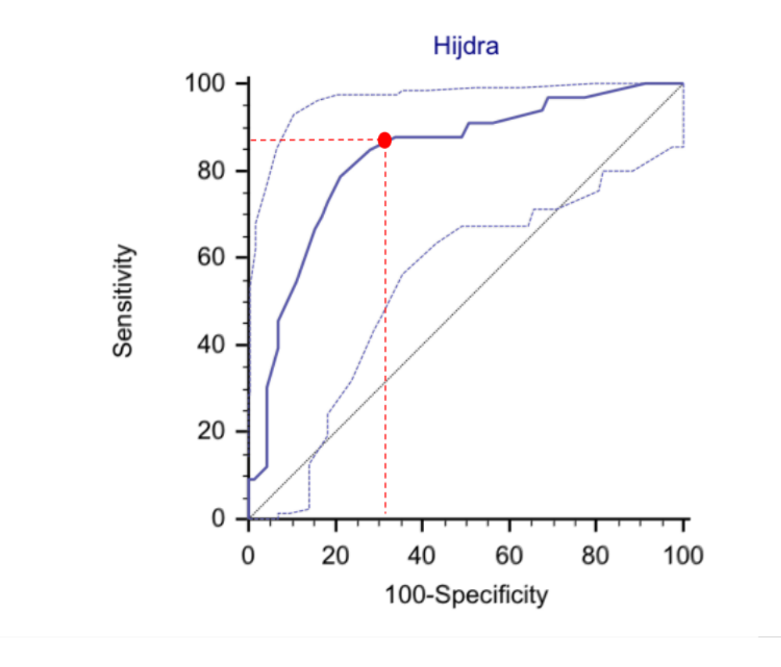

Table S1. Comparison of CT-Scan Based Grading Systems for Subarachnoid Haemorrhage and Intraventricular Haemorrhage.

Grading systems (range) |  | Fisher grade (1-4) |  | modified Fisher grade †  (0-4) |  | Claassen scale †  (0-4) |  | BNI scale †  (1-5) |  | Graeb scale  (0-12) |  |  | LeRoux scale  (0-16) |  | Hijdra scale  (0-42) |  |  | IVH score  (0-23)
 |  |  |  |  |  |  |  |  |  | For each lateral ventricle | For 3rd and 4th ventricles |  | For each ventricle |  | Sub-arachnoid compartment †  (for each cistern or fissure) | Ventricular compartment ‡  (for each ventricle) |  | For each lateral ventricle | For 3rd and 4th ventricles | Hydrocephalus
0 |  | - |  | No blood |  | No blood |  | - |  | No blood | No blood |  | No blood |  | No blood | No blood |  | No blood or small amount of layering | No blood | Absent
1 |  | No Blood |  | Thin SAH, no IVH |  | Thin SAH, no IVH in either lateral ventricle |  | No Blood |  | Trace of blood | Blood present, size normal |  | Trace of blood |  | Small amount of blood | Blood sedimentation in the posterior part |  | Up to 1/3 filled with blood | Partially or completely filled | Present
2 |  | SAH <1mm |  | Thin SAH with IVH |  | Thin SAH, IVH in both lateral ventricles |  | ≤5mm |  | < 50% filled | Filled with blood and expanded |  | < 50% filled with blood |  | Moderately filled with blood | Partly filled with blood |  | Up to 2/3 filled with blood | - | -
3 |  | SAH >1mm |  | Thick SAH, no IVH |  | Thick SAH, no IVH in both lateral Ventricles |  | >5mm and ≤10mm |  | > 50% filled | - |  | > 50% filled of blood |  | Completely filled with blood | Completely filled with blood |  | Mostly or completely filled with blood | - | -
4 |  | SAH with IVH |  | Thick SAH with IVH |  | Thick SAH, IVH in both lateral ventricles |  | >10mm and ≤15mm |  | Completely filled and expanded | - |  | Completely filled and expanded |  | - | - |  | - | - | -
5 |  | - |  | - |  | - |  | >15mm |  | - | - |  | - |  | - | - |  | - | - | -
 |  |  |  | † Definition of thin or thick SAH are not specified |  | † Thick SAH is defined by a thickness of the blood clot ≥5mm completely filing a cistern or fissure. |  | † Maximum thickness of the blood clot measured perpendicular to the most predominantly involved cistern or fissure. |  |  |  |  |  |  | † Ten cisterns are analysed: frontal interhemispheric (A); lateral sylvian fissure (two each; B), medial sylvian fissure (two each; C), suprasellar (two each; D), and ambient (two each; E); and quadrigeminal (F). Therefore, the total amount of subarachnoid blood ranges from 0 to 30 points on the scale.  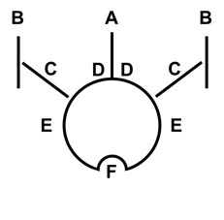  ‡ The four ventricles are analyzed. Therefore, the total amount of blood within the four ventricles ranges from 0 to 12 points on the scale. |  |  | † IVHS = 3 x (RV + LV + H ) + III + IV  where RV stands for right ventricle score, LV for left ventricle score, III for third ventricle score, IV for fourth ventricle score, and H for the presence of hydrocephalus.  The formula for converting IVHS to volume is :  IVH volume (mL) = e^{IVHS/5}

BNI denotes Barrow Neurological Institute score; IVH, intraventricular haemorrhage; SAH, subarachnoid haemorrhage

Table S2. Area Under the Receiver Operating Characteristic Curve (ROC_{AUC}) Values and Cut-off Values to Determine Occurrence of DCI, Early Hydrocephalus requiring EVD, Poor Outcome, Mortality after Aneurysmal Subarachnoid Haemorrhage. *

 |  | ROC_{AUC}  (95% confidence interval) | Optimal  Cut-off | Specificity |  |  | Sensitivity
 | Variables |  |  | Expressed in percent  (95% confidence interval)
DCI
 | Fisher Grade  modified Fisher Grade | 0.59 (0.52–0.66) #  0.67 (0.60–0.73) # | ≥3  ≥3 - | 30 (22–39)  50 (41–59) |  | 86 (76–93)  79 (69–88)
 | Claassen Scale | 0.66 (0.59–0.72) # | ≥2 | 27 (19–36) |  | 97 (91–99)
 | BNI Scale | 0.63 (0.56–0.70) # | ≥3 - | 40 (31–49) |  | 86 (76–93)
 | Hijdra Scale | 0.80 (0.74–0.85) | ≥20 | 63 (54–71) |  | 85 (75–92)
 | LeRoux Scale | 0.65 (0.58–0.71) # | ≥4 | 78 (70–85) |  | 47 (36–59)
 | Graeb Scale | 0.64 (0.57–0.71) # | ≥1 | 51 (42–60) |  | 73 (62–83)
 | Intraventricular Haemorrhage Volume Score | 0.61 (0.54-0.68) # | ≥1 | 40 (31–50) |  | 82 (72–90)
 | GCS score | 0.63 (0.56-0.69) # | ≤14 | 40 (31–49) |  | 83 (73–91)
 | WFNS Scale | 0.61 (0.53-0.67) # | ≥1 | 40 (31–49) |  | 81 (70–89)
 | SAPS II | 0.56 (0.48-0.63) # | ≥41 | 75 (67–82) |  | 37 (25–50)
Early hydrocephalus requiring EVD
 | Fisher Grade | 0.67 (0.61–0.73) † | ≥3 | 39 (24–48) |  | 95 (90–98)
 | modified Fisher Grade | 0.72 (0.66–0.78) † | ≥3 | 57 (47–66) |  | 87 (79–92)
 | Claassen Scale | 0.72 (0.66–0.78) † | ≥3 | 76 (67–84) |  | 64 (55–73)
 | BNI Scale | 0.61 (0.55–0.68) † | ≥3 | 36 (27–46) |  | 80 (72–87)
 | Hijdra Scale | 0.75 (0.69–0.80) † | ≥26 | 82 (73–88) |  | 59 (49–68)
 | LeRoux Scale | 0.80 (0.75–0.85) † | ≥2 | 69 (59–77) |  | 79 (71–86)
 | Graeb Scale | 0.82 (0.76–0.86) † | ≥2 | 78 (69–85) |  | 73 (64–80)
 | Intraventricular Haemorrhage Volume Score | 0.85 (0.79–0.89) | ≥8 | 90 (83–95) |  | 70 (31–78)
 | GCS score | 0.70 (0.66-0.78) † | ≤12 | 73 (64–81) |  | 64 (55–73)
 | WFNS Scale | 0.68 (0.61-0.74) † | ≥3 | 73 (64–81) |  | 63 (54–71)
 | SAPS II | 0.73 (0.66-0.78) † | ≥28 | 67 (57–78) |  | 77 (68–84)
Poor outcome
 | Fisher Grade | 0.61 (0.54–0.67) § | ≥3 | 29 (22–38) |  | 91 (84–96)
 | modified Fisher Grade | 0.66 (0.60–0.72) § | ≥3 - | 45 (37–54) |  | 83 (74–90)
 | Claassen Scale | 0.71 (0.64–0.76) § | ≥3 | 68 (59–76) |  | 65 (54–74)
 | BNI Scale | 0.73 (0.67–0.78) § | ≥4 - | 73 (65–80) |  | 65 (54–74)
 | Hijdra Scale | 0.73 (0.67–0.79) § | ≥23 | 66 (57–74) |  | 72 (62–81)
 | LeRoux Scale | 0.70 (0.63–0.76) § | ≥4 | 78 (70–85) |  | 60 (50–70)
 | Graeb Scale | 0.70 (0.63–0.76) § | ≥3 | 76 (68–83) |  | 58 (47–68)
 | Intraventricular Haemorrhage Volume Score | 0.68 (0.62–0.74) § | ≥7 - | 66 (57–74) |  | 65 (54–74)
 | GCS score | 0.79 (0.73-0.84) | ≤12 | 75 (67–82) |  | 77 (67–85)
 | WFNS Scale | 0.79 (0.74-0.84) | ≥2 | 70 (61–77) |  | 83 (74–90)
 | SAPS II | 0.83 (0.77–0.88) | ≥33 | 72 (63–79) |  | 83 (74–90)
* Data for DCI were collected from a collective of 200 patients (30 patients who died before day 7 were excluded).
Data for poor outcome, early hydrocephalus requiring EVD and mortality were collected from a collective of 230 patients.
# ROC_{AUC} significantly different than the one of the Hijdra scale (p<0.05). † ROC_{AUC} significantly different than the one of the Intraventricular Haemorrhage Volume Score (P<0.05).
§ ROC_{AUC} significantly different than the one of the SAPS II scale (p<0.05).
BNI denotes average Barrow Neurological Institute; DCI, Delayed Cerebral Infarction; EVD, External Ventricular Drain; GCS, Glasgow Coma Scale; SAH, Subarachnoid Haemorrhage; SAPS, Simplified Acute Physiology Score and WFNS, World Federation of Neurological Surgeons Grading System.

 |  | Poor outcome |  |  | DCI† |  |  | Early hydrocephalus
 | Numerical values* | Odds ratio [95% CI] | P value |  | Odds ratio [95% CI] | P value |  | Odds ratio [95% CI] | P value
Clinical characteristics
Age | 18-87 | 1.0 [1.0-1.1] | 0.003 |  | 1.0 [1.0-1.0] | 0.20 |  | 1.0 [1.0-1.0] | 0.51
Male sex | 0, 1 | 1.8 [1.0-3.3] | 0.06 |  | 1.2 [0.7-2.1] | 0.59 |  | 1.3 [0.8-2.2] | 0.35
SAPS II | 0-163 | 1.1 [1.1-1.1] | <0.001 |  | 1.0 [1.0-1.0] | 0.12 |  | 1.1 [1.0-1.1] | 0.05
WFNS scale | 1-5 | 2.3 [1.8-3.1] | <0.001 |  | 1.2 [1.0-1.5] | 0.02 |  | 1.6 [1.3-1.9] | <0.001
GCS | 3-15 | 0.8 [0.7-0.8] | <0.001 |  | 0.9 [0.9-1.0] | 0.03 |  | 0.8 [0.8-0.9] | <0.001
Aneurysm Clipping | 0, 1 | 4.2 [2.2 -8.0] | <0.001 |  | 0.6 [0.3-1.3] | 0.22 |  | 0.8 [0.4-1.4] | 0.43
Neurogenic pulmonary oedema | 0, 1 | 0.6 [0.1 -2.2] | 0.46 |  | 6 [1.6-46] | 0.02 |  | 1.4 [0.4-5.5] | 0.63
CT scan findings
Intracerebral hematoma | 0, 1 | 2.5 [1.3 -4.7] | 0.005 |  | 0.8 [0.4-1.6] | 0.55 |  | 1.3 [0.7-2.2] | 0.44
Rebleeding | 0, 1 | 4.1 [1.6 -10.5] | 0.003 |  | 0.8 [0.3-2.3] | 0.74 |  | 2.4 [0.9-7.0] | 0.08
Ruptured aneurysm MCA | 0, 1 | 2.4 [1.3-2.6] | <0.001 |  | 0.7 [0.4-1.5] | 0.45 |  | 0.6 [0.3-1.2] | 0.16
Fisher grade | 1-4 | 4.6 [1.9-17.8] | 0.005 |  | 2.4 [1.4-4.4] | 0.003 |  | 6.8 [3.4-16.4] | <0.001
modified Fisher grade | 0-4 | 3.5 [1.5-7.9] | 0.001 |  | 2.7 [1.8-4.4] | <0.001 |  | 3.0 [2.1-4.7] | <0.001
Claassen scale | 0-4 | 2.8 [1.7-4.8] | <0.001 |  | 2.4 [1.6-3.6] | <0.001 |  | 2.7 [1.9-3.9] | <0.001
BNI grading scale | 1-5 | 2.9 [2.0-4.2] | <0.001 |  | 1.8 [1.0-3.3] | 0.001 |  | 1.6 [1.2-2.1] | <0.001
Hijdra scale | 0-42 | 1.1 [1.1-1.2] | <0.001 |  | 1.1 [1.1-1.2] | <0.001 |  | 1.1 [1.1-1.1] | <0.001
Graeb scale | 0-12 | 1.2 [1.1-1.3] | <0.001 |  | 1.1 [1.0-1.2] | 0.01 |  | 1.5 [1.3-1.7] | <0.001
Leroux scale | 0-16 | 1.2 [1.1-1.2] | <0.001 |  | 1.1 [1.1-1.2] | 0.008 |  | 1.3 [1.0-1.1] | <0.001
IVH score | 0-23 | 1.1 [1.1-1.2] | <0.001 |  | 1.0 [1.0-1.1] | 0.04 |  | 1.3 [1.2-1.4] | <0.001

Table S3. Univariate Risk Factors for Poor Patient Outcome (GOSE 1-4), Delayed Cerebral Infarction (DCI) and Early Hydrocephalus Requiring EVD.

* 0=no, 1=yes. †Data for DCI were collected from a collective of 200 patients (30 patients who died before day 7 were excluded).
Boldface values represent significant findings assumed at P-values of .05 and below.
The odds ratio needs to be interpreted as follows: for example, each point increase in Hijdra scale, the risk for DCI increases by 10% (95% CI, 3%–10%).
CI denotes Confidence Interval; BNI, Barrow Neurological Institute score; GCS, Glasgow Coma Scale; GOSE, Extended Glasgow Outcome; IVH, Intraventricular Haemorrhage; SAPS II, Simplified Acute Physiologic Score II and WFNS, World Federation of Neurological Surgeons Grading System.

Table S4. Comparison of Kappa Values (κ) between Observers for the Different Qualitative Scales and Quartile Distribution of Semi quantitative and Quantitative Values.

 | Grading systems | κ value | 95% confidence interval | Strength of agreement
 | Fisher Scale  Fisher modified Scale | 0.91  0.80 | 0.75–1.00  0.57–1.00 | Very good  Good
 | Claassen Scale | 0.70 | 0.48–0.92 | Good
 | BNI Scale | 0.72 | 0.54–0.90 | Good
 | Hijdra Scale | 0.85 | 0.80–0.91 | Very good
 | Leroux Score | 0.84 | 0.74–0.94 | Very good
 | Graeb Score | 0.85 | 0.75–0.94 | Very good
 | IVH Score | 0.69 | 0.56–0.83 | Good

BNI denotes average Barrow Neurological Institute and IVH; Intraventricular Hemorrhage.

